**Tribhuvan University**

**Faculty of Humanities and Social Sciences**

**A PROJECT REPORT ON**

**Online Agriculture Solution**

**Submitted to:**

**Department of Computer Application**

**Sungava College, Khairahani Chitwan**

***In partial fulfillment of the requirements for the***

***Bachelors of Computer Application***

**Submitted by:**

|  |  |
| --- | --- |
| Name: Garima Dhital Reg. Number: 6-2-1095-14-2019 | Name: Agraj Adhikari  Reg. Number: 6-2-1095-3-2019 |

Under the Supervision of

**Nischal Khatiwada**

**29th September 2023**



**Tribhuvan University**

**Faculty of Humanities and Social Sciences**

**Sungava College**

**Supervisor’s Recommendation**

I hereby recommend that this project prepared under my supervision by Garima Dhital and Agraj Adhikari entitled **“Online Agriculture Solution”** In partial fulfillment of the requirements for the degree of Bachelor of Computer Application is recommended for the final evaluation.

**_________________**

Nischal Khatiwada

Supervisor

BCA Department

Sungava College

Khairahani-6, Chitwan



**Tribhuvan University**

**Faculty of Humanities and Social Sciences**

**Sungava College**

**LETTER OF APPROVAL**

This is to certify that this project prepared by Garima Dhital and Agraj Adhikari entitled **“Online Agriculture Solution”** in partial fulfillment of the requirements for the degree of Bachelor in Computer Application has been evaluated. In our opinion it is satisfactory in the scope and quality as a project for the required degree.

|  |  |
| --- | --- |
| **__________________**  **Nischal Khatiwada**  **Supervisor**  **BCA Dept.**  **Sungava College** | **___________________**  **Hari Prasad Sapkota**  **Program Coordinator**  **BCA Dept.**  **Sungava College** |
| **_____________________**  **Nischal Khatiwada**  **Internal Examiner**  **BCA Dept.**  **Sungava College** | **____________________**  **Name:**  **External Examiner** |

# **Abstract**

This software helps us to manage information of and about OAS projects. As we know that information is a key term to success. So, this software manages all the information of agriculture materials and services. This OAS (Online Agriculture Solution) aims to provide one click information access. The design used in this software helps us to attract user attraction in first view, which can be the best way of managing information.

This software is dynamic and the interfaces can be changed according to organization and requirement. So, it can be used by any Agriculture Solution for managing their information, as a part of an information provider to their organization. This will help any organization to change the content time and again.

In this software, latest trends of software development tools, PHP has been used as the front-end tools and, MySQL has been used as the back-end tools along with the framework Laravel. These two software development tools are widely being used in developing web-based applications in today’s time.

# **Acknowledgement**

We are thankful to our respected project Guide Nischal Khatiwada for his persistence help throughout completion of this project. His suggestions and guidance in every stage is one of the major reasons of successful completion of my project. Without his proper guidance our project would not has been accomplished on time.

We would like to express our sincere thankfulness to Mr. Hari Prasad Sapkota, Co-Ordinator, BCA program, Sungava College, for encouraging us to develop this software. During the pre-development stage, developing state and post-developing stage, he always remained the source of inspiration and encouragement for us to complete this project in time.

A bit closer to our home, we would like to add my heartfelt appreciation for our parents for their infinite kindness and patience throughout our academic career.

Many thanks to Sungava College, for providing us the great platform on the field of computer education and generously providing the relevant resources. We are thankful to Mr. Prakash Chhetri, for helping us in every aspect of the academic years in Sungava. We are also thankful to Mr. Sobraj Paudel, and all staff members of the Sungava College for their kind support.

Finally, we would like to thank all of hidden concern bodies who helped us to meet my goal on this time and future too.

**Thank you!**

Name: Garima DhitalName: Agraj Adhikari

Signature Signature

**Table of Contents**

**Abstract** iii

**Acknowledgement** iv

**List of Abbreviations** vii

**List of Figures** viii

**List of Tables** ix

**Chapter 1: Introduction** 1

**1.1** **Introduction** 1

**1.2 Problem Statement** 1

**1.3 Objectives** 2

**1.4 Scope of the system** 2

**1.6 Report Organization** 3

**Chapter 2: Background Study and Literature Review** 4

**2.1 Background Study** 4

**2.2 Literature Review** 4

**Chapter 3: System Analysis and Design** 6

**3.1 System Analysis** 6

**3.1.1 Requirement Analysis** 6

**3.1.2 Feasibility Analysis** 7

**3.1.3 Data Modeling** 9

**3.2 System Design** 12

**3.2.1 Schema Design** 13

**3.2.2 Interface Design** 13

**3.3 Alogrithm Details:** 16

**Chapter 4: Implementation and Testing** 19

**4.1 Implementation** 19

**4.1.1 Tools Used** 19

**4.2 Testing** 19

**4.2.1 Testing Plan** 20

**4.2.2 Test Reports** 21

**Chapter 5: Conclusion and Future Recommendations** 22

**5.1 Lesson Learnt/Outcome** 22

**5.2 Conclusion** 22

**5.3 Future Recommendations** 22

**Appendix A** 23

**Appendix B** 29

**References** 33

# **List of Abbreviations**

OFS : Online Agriculture Solution

SQL : Structured Query Language

# **List of Figures**

**Figure 3.1. 1 Iterative Method** 6

**Figure 3.1. 2** **CASE Diagram of Online Agriculture Solution** 7

**Figure 3.1. 3** **Level 0 DFD of OAS** 9

**Figure 3.1. 4** **First Level DFD For Admin** 10

**Figure 3.1. 5** **First Level DFD For User** 10

**Figure 3.1. 6** **Second level DFD of Admin** 11

**Figure 3.1. 7 Second Level DFD Of User** 12

**Figure 3.2. 1 Database Schema** 13

**Figure 3.2. 2 Login Page** 13

**Figure 3.2. 3 Registration Page** 14

**Figure 3.2. 4 Admin Dashboard** 14

**Figure 3.3. 1 Algorithm OF OAS** 18

**Figure 4.1. 1 Testing In OAS** 19

# **List of Tables**

No table of figures entries found.

**Table 4. 1: Test Reports** 21

# **Chapter 1: Introduction**

## **Introduction**

This project is about **“Online Agriculture Solution”** that allows users to check for different agriculture materials and services available at the system. The project provides a list of agriculture materials and services displayed online in various categories. The user may browse through these services. If the user wants to have any agriculture related materials, he/she may contact us through this system. Keeping the features of agricultural products, an Online Agriculture Solution project acts as a central database containing various agricultural materials and services. It provides customers online browsing facilities from their homes. A customer can sign up for free, login to his / her account can browse services of his / her own need, and can view products, buy products and can rate and reviews the products.

## **1.2 Problem Statement**

At present, the public can only know about the agricultural materials by going at its field. But in the absence of this system there occurs lots of problems.

Major problems are:

1. Tedious and time consuming to search the agricultural materials at reliable price.
2. Less or no option on the purchase of materials.
3. No centralized database for agricultural materials and their dealers.
4. No online information regarding agricultural materials like insecticides and pesticides.

## **1.3 Objectives**

The main objective of this project is to automate the complete operation of the agriculture related product and services.

Major objectives are:

1. To make easier for a customer to search and deal with the products through online.
2. To design a system that will provide various choices to the customer with the detail description of the agricultural needs and materials.
3. To make the dealer easier to deal with customers.
4. To digitalize agriculture industry.
5. To promote fast and reliable services to the customers.
6. To provide synchronized and centralized database that can be retrieved.
7. To enter and preserve details of the various product, orders placed, payments, issues and keep a track of the information and user needs and current demand.

## **1.4 Scope of the system**

The system is helpful to computerize all the activities related to online flower store. The main scope and deliverables of the project would be to:

* It will help in maintaining complete information about products and customer details.
* It will help in stock management.
* It provides online payment system.
* Staffs or the shop owner will be able to trace products and can make effective running of the store.
* All the difficulties of the paper work and manual functionalities will be eliminated due to the computerization of all store functionalities.
* Database to store, hold and retrieve the data and information and is less prone to error.

## **1.6 Report Organization**

This report is organized in five chapters, as indicated in the Table of Contents. These chapter deal with the important aspects of the Systems Development Life Cycle. Each of the chapters is divided into Headings and Sub-Headings. Chapter 1 introduces the project, its objectives and scopes. The background study and literature review are explained in Chapter 2. Chapter 3 broadly deals with the requirements, analysis and design. Chapter 4 includes the implementation and testing of the system. The test reports and testing of the working of the system is discussed here. Chapter 5 deals with the conclusion and recommendations of the system. At the end of the report, the references made the glossary along with appendices have been included. Appendix A includes screenshots and Appendix B includes source code of the system.

# **Chapter 2: Background Study and Literature Review**

## **2.1 Background Study**

Online Agriculture Solution is e-commerce website for selling agricultural items and tools which helps ranchers in buying the cultivating items like seed, pesticide, fertilizers. In order to understand the concepts associated with Online Agriculture Solution and computer-based records management systems, it is imperative to examine and analyze published material from experts regarding the field. The point of proposition is to facilitate current young and future farmers, who are keen on cultivating however they won't have any thought on cultivating, in this application client can buy manures, by looking into their details. If the farmers want to buy the products from the Agriculture Solution, it provides essential details of the item so that without any confusion farmers can buy it whole heartedly. The purpose of this review is to analyze and examine and obtain experience as regards to the creation and archival processing of electronic agricultural tools, materials and services management and electronic records, and contains an overview of the main concepts associated with the creation of an electronic records management system from the perspective of published experts.

## **2.2 Literature Review**

A literature review entails providing an overview of the literature pertaining to a specific field or subject. It serves the purpose of comprehending and critically examining previous research conducted in the background, as well as identifying and locating the sources of information essential for contextualizing the current research. Online Agricultural Store refers to the processes needed to successfully complete an online agricultural project. Agricultural project managers ensure that all elements of a project are supported and executed efficiently throughout the project lifecycle. At its most fundamental level, agriculture project management handles the planning, coordination, and execution of a project, whether it’s insecticides, pesticides, fertilizers and agricultural tools.  Currently available websites which are based on Agriculture has modules only for showing the product and some information about the products required for farming and other few websites provide few information related to agriculture but the farmers are not given complete information which is required for him like product information with price and location to purchase, for this he has to visit multiple sites but still we cannot assure that he will get information which he was searching for. Since many farmers are not aware of new technologies which are introduced in the field of agriculture they are following the old and traditional way of doing agriculture. It results in low yields and requires much effort because of this many youngsters are choosing different fields as their career. E-commerce is clearly beginning to have a major impact in the agricultural sector. The way people go about purchasing agricultural products is of great concern. Most of the time customers have to travel far distances to get agricultural products and getting the right quality is not ensured. Besides, farming is the prime occupation in Nepal. Nepali people involved in farming are mostly cheated by the agents in today’s market which leads to poverty. Our project aims to help farmers as well as customers for buying and selling agricultural products across the country using a computerized approach.

The website will guide the farmers to access new farming techniques, compare current market rate of different products, the total sale and the earned profit for the sold products. The website will act as a unique and secure way to perform agro-marketing. This project allows viewing various products available enables users to purchase desire products instantly by online payment. This website would be developed using web service as the communication infrastructure between the buyer and farmers and also products selling.

Also, customers can view products and order for the required products. We provide category page through which user can easily view the products, buy the products and can give us feedbacks or ask questions in forum. Our system is very simple so people with a little knowledge about technology can use.

# **Chapter 3: System Analysis and Design**

## **3.1 System Analysis**

We used the Iterative methodology while building this application. This project doesn’t have fixed specification, ample time and enough resources so iterative methodology was used to build the system.

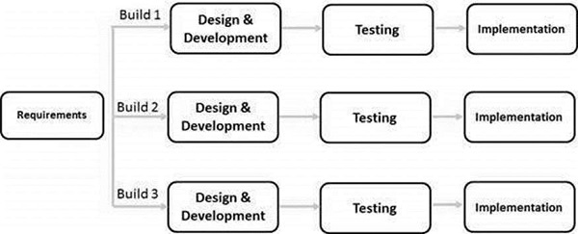

**Figure 3.1. 1 Iterative Method**

### **3.1.1 Requirement Analysis**

Requirements Analysis is the process of defining the expectations of the users for an application that is to be built or modified. Requirement analysis is critical to the success of a development project. It takes all the tasks that determine the needs for our projects.

**i) Functional Requirements:**

Functional requirements define the capabilities and function that a system must be able to perform successfully. The functional requirements of the Online Agriculture Solution System include:

* Viewers can get all the information with login.
* Viewers can register and login to the system.
* Admin can add / delete/update categories and products.
* Users can search, view, purchase and pay online.
* Users can ask questions and discuss in forum before the purchase about the product details.

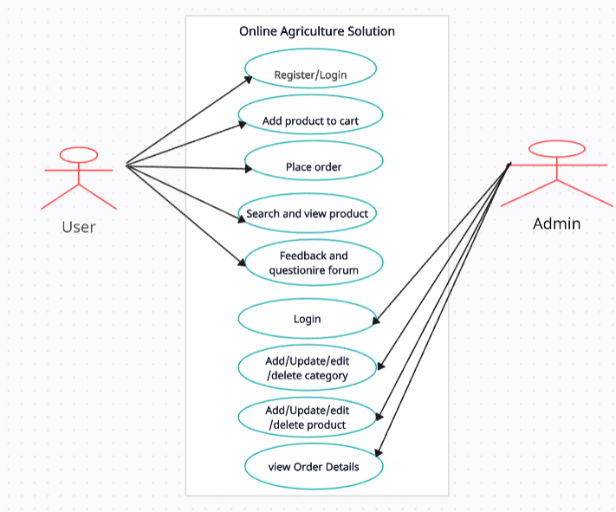

**Figure 3.1. 2** **CASE Diagram of Online Agriculture Solution**

**ii) Non-Functional Requirements**

Since the system is used in an online agriculture solution, it is a must to ensure that everything is doing well especially with the delivery of agricultural materials. Few nonfunctional requirements are as follows:

* **Usability:** The system must fulfill its’ own objectives. All the modules and functions of the system should be usable. It is important to ensure that every function is meaningful to the system.
* **Responsiveness:** The system must respond every request from the user in very few seconds in order to decrease the waiting time of the customers. Responsiveness is one of main concern during the system implementation.
* **Reliability:** The system should be reliable all the time. The functions in the system should produce the correct output to the user.

### **3.1.2 Feasibility Analysis**

A feasibility study is a preliminary study undertaken to determine and document a project work is achievable by the use of current technology and other related terms. The objective of feasibility study conducted to analyze and understand the technical, behavioral, legal, time and economic prospects for developing the system prior to actually using resources to develop it.

**Table 3. 1: Feasibility Analysis**

|  |  |  |
| --- | --- | --- |
| **Nature of Feasibility** | **Whether Feasible** | **Reason** |
| **Technical Feasibility** | Do we currently possess the necessary technology? | Although the users of the system are spread over a wide area, due to the use of broadband internet at the locations and commonly available technologies. The organization will buy all the necessary technology for example the Pc’s, Routers, Blade Servers, WAN devices, etc. |
| **Economic Feasibility** | Is the system cost-effective? Do benefits outweigh costs? | Reduce hazardous waste costs, Insurance of liabilities, decrease maintenance and operating costs, decrease in man power costs makes it feasible even though installation cost may be high but in terms of long run it is very feasible. |
| **Legal Feasibility** | Determines whether the proposed system have a legal impact or not. | As the operation of system is under the existing protocol to the ecommerce site and government rules, the system is legally feasible. |
| **Operational Feasibility** | Determines whether the system will operate in the way that user wants or not. | Procedures are based on the manual system described by the users need. Users are not required to be trained on procedural aspects. Hence it is operationally feasible. |
| **Schedule Feasibility** | Determines whether the system will be completed in a sanctioned time or not. | This system is supposed to developed in 10 weeks if object orientation and code reuse are adopted. Hence the feasible to complete the system as per required schedule. Feasible to complete the system as per the schedule. |

### **3.1.3 Data Modeling**

Data modeling answers a set of specific questions that are relevant to any data processing application. When data modeling is done, it is the first steps towards structuring and organizing of data. These data structure are then typically implemented in a database management system. In addition to defining and organizing the data, data modeling will impose (implicitly or explicitly) constraints or limitations on the data placed within the structure. The analysis of data objects and their relationships to other data objects. It involves a progression from conceptual model to logical model to physical schema.

**3.1.4 Process Modeling**

A data flow diagram (DFD) is a graphical representation that depicts information flow and the transforms that are applied as data move from input to output. The context level data flow diagram is known as Level 0 DFD. It represents the system level description of the processes explaining how the system interacts with external entities.

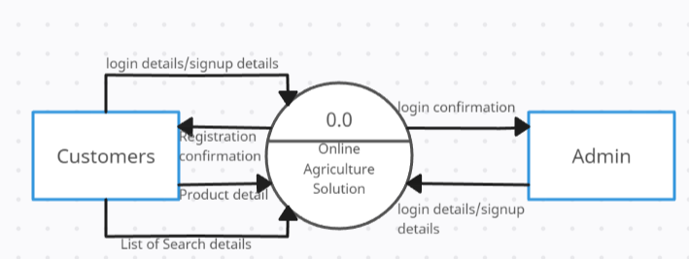

**Figure 3.1. 3** **Level 0 DFD of OAS**

#### **3.1.4.1 First level DFD for Admin**

After entering to the home page of the website, admin can LOGIN where they are asked to enter username & password, and if he/she is a valid user then admin login page will be displayed and can get access to whole system.

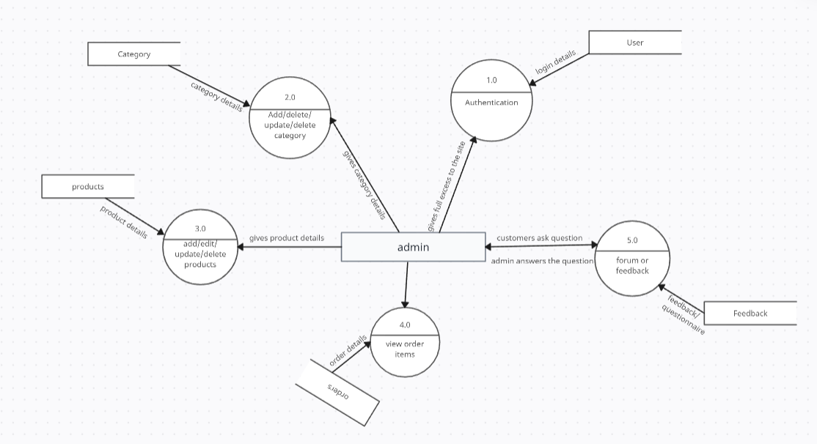

**Figure 3.1. 4** **First Level DFD For Admin**

#### **3.1.4.2. First level DFD of User**

After entering to the home page of the website, users can LOGIN where they are asked to enter username & password, and if he/she is a valid user then a user login page will be displayed and can have access to some operations.

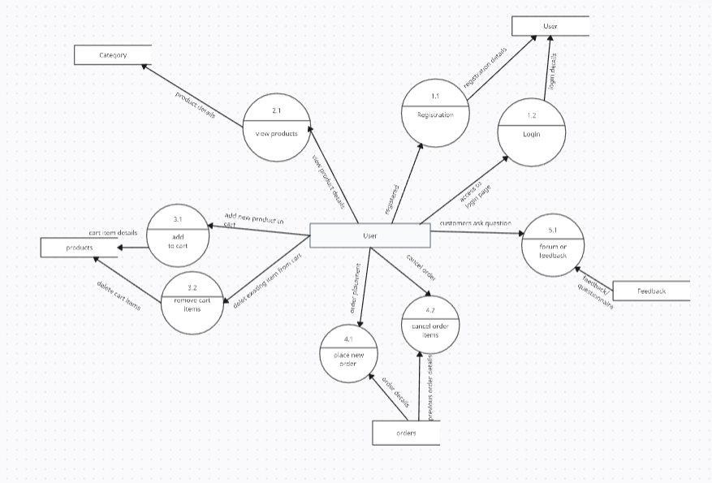

**Figure 3.1. 5** **First Level DFD For User**

**3.1.4.3 Second Level DFD of Admin**

After the home page login admin can add/delete/update categories and products which details stored in categories and products table respectively. S/He can also view the order details and deliver the products.

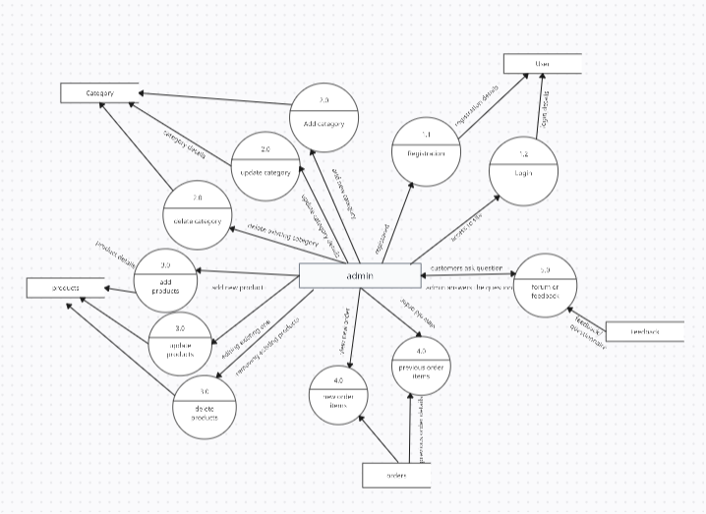

**Figure 3.1. 6** **Second level DFD of Admin**

**3.1.4.4 Second Level DFD of User**

After the home page login user can add products to cart, place order and give reviews and ratings to the products which details are stored in cart table, order table, reviews table and ratings table respectively.



**Figure 3.1. 7 Second Level DFD Of User**

## **3.2 System Design**

The system is designed using the Model View Controller (MVC) Architecture. MVC is a system architecture that separates application into three main components, namely the model, view and controller, each playing different roles. Model is the main functionality or the domain-specific representation of the information, views are the user interfaces and the controllers are the ones who respond to user actions and invoke appropriate changes on the model and view. The purpose of separating the application is to make sure that the modification to one component will cause the least impact to the others and thus promoting system maintainability.

### **3.2.1 Schema Design**

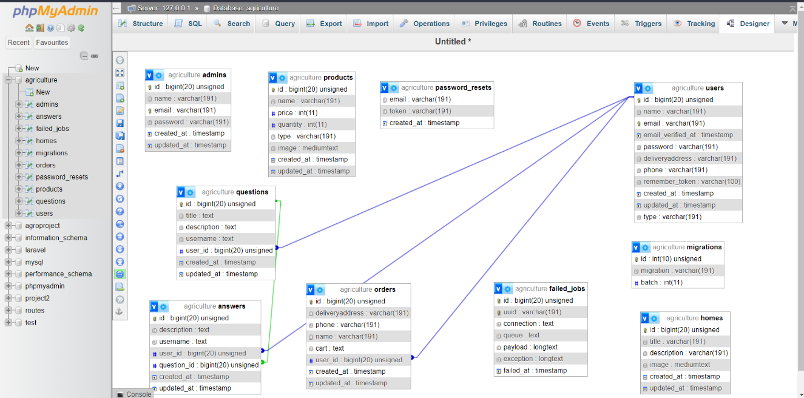

**Figure 3.2. 1 Database Schema**

### **3.2.2 Interface Design**

**Login page:**

The page requires email and password to start the application. Both the user and admin can login from the same page. Login is a process by which individual access to a computer system is controlled by identifying and authenticating the user through the cardinalities presented by the user. Admin can add update or delete the product and services etc.

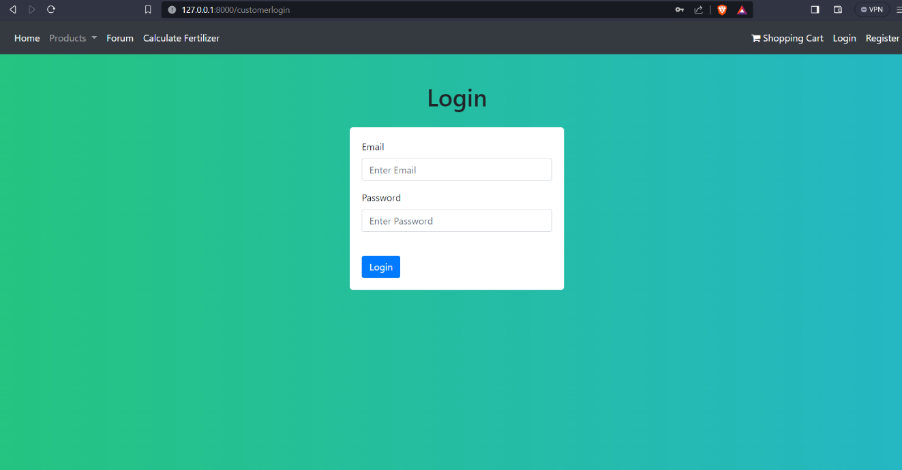

**Figure 3.2. 2 Login Page**

**User and admin registration:**

User can register the account by fill the information about you and click on signup button. He/she can add the account for the further enquiry of the construction projects. The users have to login to get more information about the construction project.

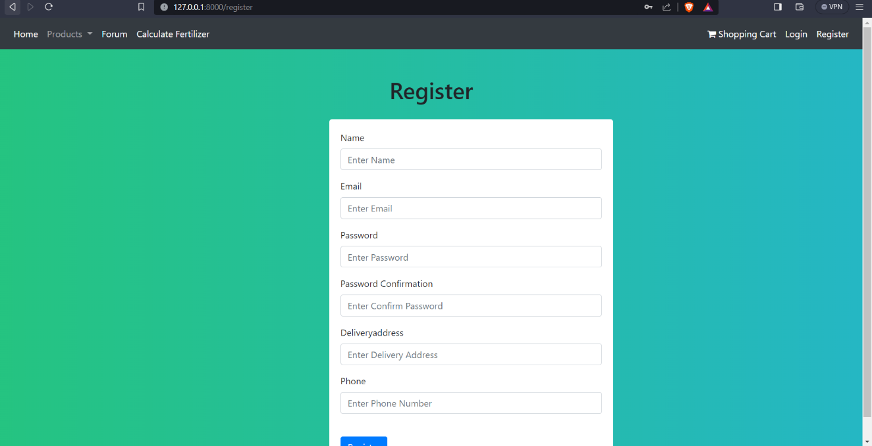

**Figure 3.2. 3 Registration Page**

**Users are of two types:**

**Admin level user:**

Admin level user are an admin user, if he/she login an admin panel they work on an all the pages of the admin site like add user, update user, delete user, add, update and delete product and services.

**Figure 3.2. 4 Admin Dashboard**

**General Level User:**

General level user is a general user, if he/she login an admin panel they do not see all the pages of the admin site like add user, update user, delete user, add, update and delete product and services etc. They work on only an addition of the new user and can get access to user level services etc.

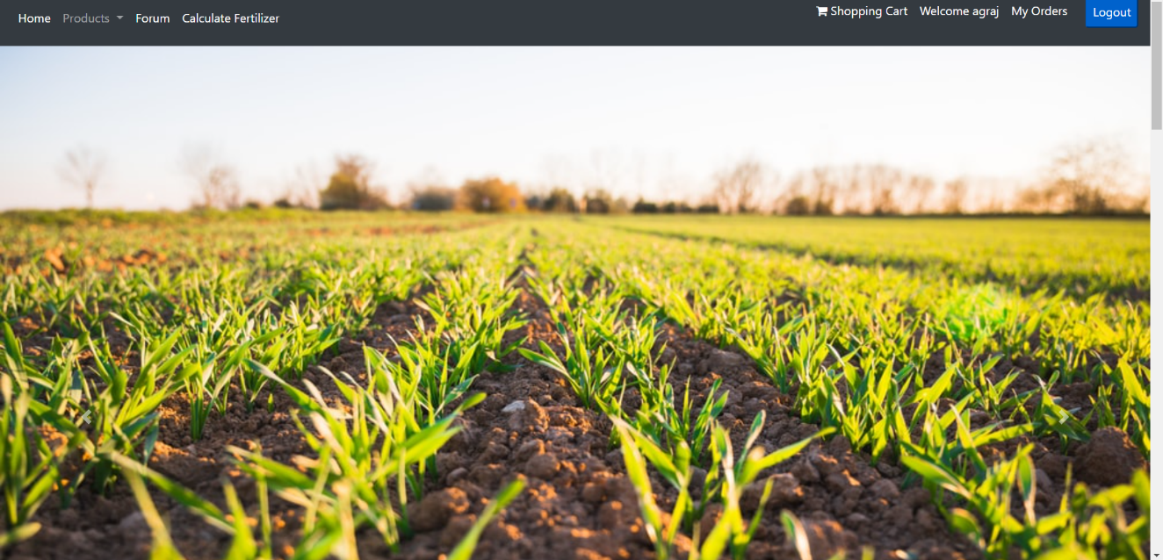

**Main Window:**

An Online Agriculture Solution is a great project. This project is designed for successful completion of project on online Agriculture system. The basic building aim is to provide agricultural product and services to the customers. Online Agriculture Solution (OAS) is a web-based system that is designed to provide product and services to the customer. This project aims to maintain all the information pertaining to agricultural projects, different agriculture related product and services available there and helps them manage in a better way.

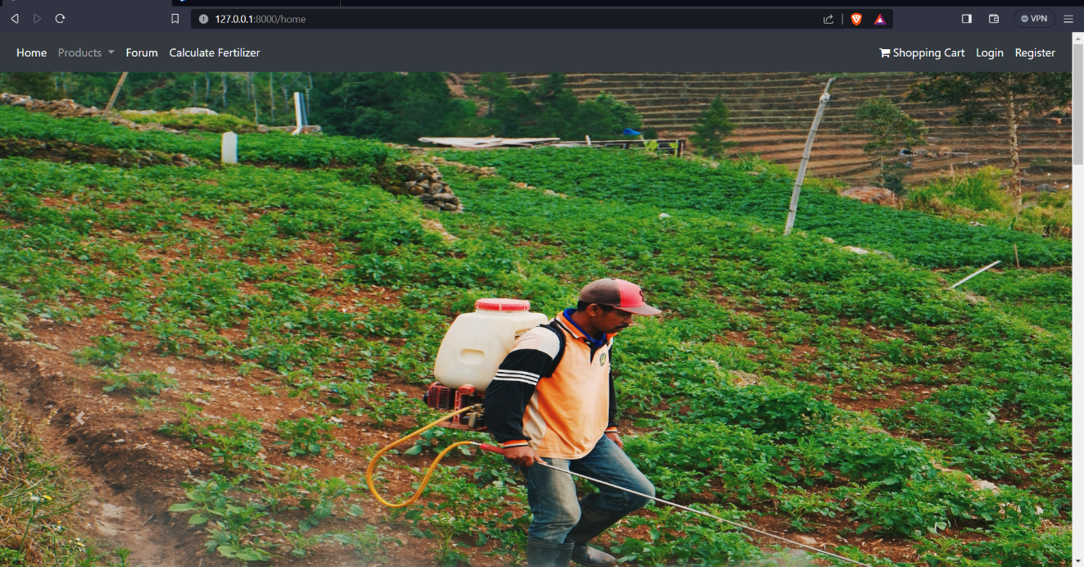

## **3.3 Alogrithm Details:**

The Quantity Calculator Algorithm in the Online Agriculture Solution computes the Mass Index of Agricultural Goods of a user based input of their land. It involves multiplying the area of land in katha with the constant given amount of fertilizers such as for dap its 2.7, urea its 1 and potass it’s 0.7. This algorithm aids in land tracking and guides personalized agricultural plans with Online Agriculture Solution.

**Coding:**

@extends('Customer.layouts.app')

@section('content')

<!DOCTYPE html>

<html lang="en">

<head>

<meta charset="UTF-8">

<meta name="viewport" content="width=device-width, initial-scale=1.0">

<title>Fertilizer Calculator</title>

<link rel="stylesheet" href="style.css">

</head>

<body>

<div class="container">

<h1>Fertilizer Calculator</h1>

<div class="input-container">

<label for="height">Area in acre:</label>

<input type="number" id="height" placeholder="Kattha"><br>

<span id="message"></span>

</div>

<button onclick="calculateBMI()">Calculate</button>

<div id="result"></div>

</div>

<script data-two_delay_id="two_65605c88e3d99" data-two_delay_src="script.js"></script>

<script>

function calculateBMI(){

const area = document.getElementById('height').value;

const dap = (area*2.7).toFixed(2);

const urea = (area*1).toFixed(2);

const potass = (area*0.7).toFixed(2);

const message = document.getElementById('message');

message.innerHTML=' you need .....<br>'+dap+' kg of DAP <br>'+urea+' kg of urea<br> '+potass+' kg of potass';

console.log(dap,urea,potass)

}

</script>

</body>

</html>

@endsection

**Formula:**

const dap= (“area*2.7). toFixed(2);

const urea= (“area*1). toFixed(2);

const potass =(area*0.7). toFixed(2);

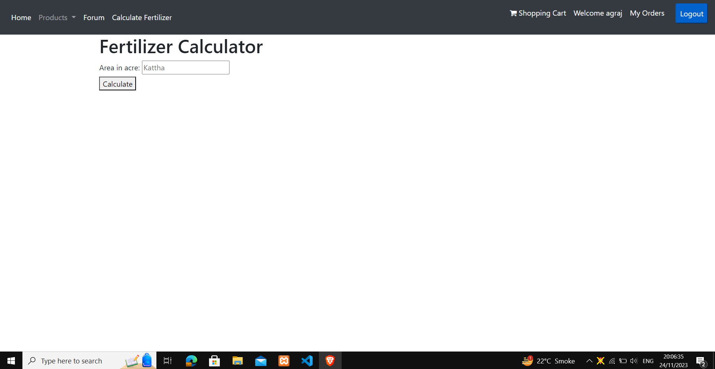

**Figure 3.3. 1 Algorithm OF OAS**

# **Chapter 4: Implementation and Testing**

## **4.1 Implementation**

During the software implementation phase, each module of software is thoroughly tested for bugs and for accuracy of output. The system developed is very user-friendly and the detailed documentation is also given to the user as online help wherever necessary. The implementation phase normally ends with the formal test involving all the components.

### **4.1.1 Tools Used**

* Laravel: It is a framework to design wed-based projects. A web framework provides a structure and starting point for creating your application, allowing you to focus on creating something amazing while we sweat the details.
* MySQL: It is mainly used to communicate with databases. As such, it’s used by server, developers, data administrations.
* Bootstrap: It is an Open Source CSS framework directed at responsive, contains HTML, CSS and JavaScript.
* PHP: In our project Construction Management System, we use the PHP because it is easy to manage the dynamic content.

## **4.2 Testing**

A test plan is a document describing the scope, approach, resources, and schedule of intended testing activities. It identifies test items, the features to be tested, the testing OAS, who will do each OAS, and any risks requiring contingency planning.

|  |
| --- |
| System Testing  Validation Testing  Functional Testing  Integration Testing  Unit Testing |

**Figure 4.1. 1 Testing In OAS**

### **4.2.1 Testing Plan**

Test Objectives: Testing the system using sample data.Test Data Valid: Prepared few sets of data of for different classes

Invalid: Tried to enter the cross link entry of sample data from the gathered samples.

Output Valid: The valid data easily traveled in the expected way but the invalid data rejected by the system.

Test objectives: Test for valid username and password entry

Test data:

Valid: Entered valid username and password

Invalid: Roughly entered some alphanumeric characters as input

Output:

Valid: Allowed access to the system

Invalid: Ask to enter the right username and password

Result:

Valid: The user was allowed to enter the system.

Invalid: The user couldn’t enter the system.

Conclusion Both valid and invalid input gave desired output.

Test objectives: Test for acceptance of data

Test data:

Valid: Entered some valid data in key field of the database.

Invalid: Entered invalid data in the key field.

Output:

Valid: Entry accepted.

Invalid: Entry discarded.

Result:

Valid: valid data entered easily in to the database.

Invalid: Invalid data couldn’t be entered.

Conclusion: Both valid and invalid data gave desired output.

### **4.2.2 Test Reports**

Since this test concentrates on each unit of the software as implemented in source code, the test was conducted keeping every small module in consideration. The following is the report of a few bugs that were overcome during the test and those remain unchecked.

**Table 4. 1: Test Reports**

|  |  |  |  |  |
| --- | --- | --- | --- | --- |
| **S. N** | **Test case** | **Input data** | **Expected outcome** | **Actual result** |
| 1. | Login page | Correct username & password | User must login successfully | User logged in |
| 2. | Login page | Correct username & invalid password | User must not login | User can’t login |
| 3. | Login page | Incorrect username & valid password | User must not login | User can’t login |
| 4. | Login page | Incorrect username & invalid password | User must not login | User can’t login |
| 5. | Register page | Numbers in Name field | A message is shown “Name doesn’t contain numbers” | User can’t register |
| 6. | Register page | Invalid phone numbers | A message is shown “starts with 98—and exact 10 “ | User can’t register |
| 7. | Register page | Already existing username | A message is shown “username already exists” | User can’t register |
| 8. | Register page | Password less than 7 character | A message is shown “Password must be >7” | User can’t register |

Most of the error is caused by human because human develop system and manipulation is done by human themselves only, hence nobody can deny the possibility of having committing some or other mistake or the existence of bugs. A set of test materials is nothing more than a list of possible problems in a program and a set of procedure for determining whether the problems actually exist and are significant or not.

# **Chapter 5: Conclusion and Future Recommendations**

## **5.1 Lesson Learnt/Outcome**

The system was able to attain some of the goals that were set the beginning of development. Below are a few of those goals that were reached:

* The system can adequately keep user records for future reference.
* The system can generate a list of product and services with their price and details.
* The system is able to generate report on particular flowering components.
* All the process of submission of registration form is quite simple.

## **5.2 Conclusion**

The ultimate goal and aim of the project were to create an Online Flower Store that provides quick and instant access to product and services records. This objective has been met.

The application meets all the user requirements and is usable in a local environment such as flower related online store to provide a quick access to the user records as well as management.

## **5.3 Future Recommendations**

For the further recommendations, this software can be converted to mobile apps so that it would be easy for operation from the mobile devices too.

# **Appendix A**

**Screen Shots**

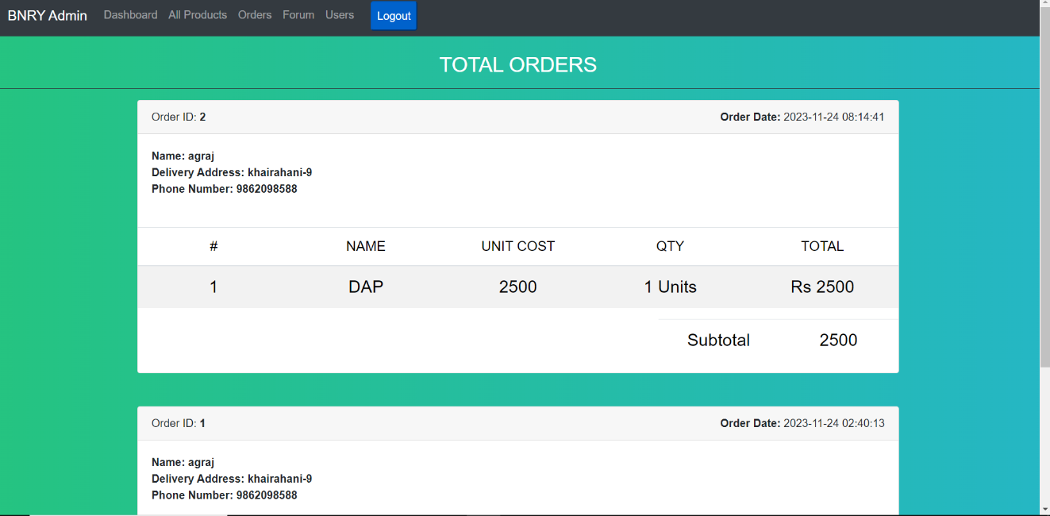

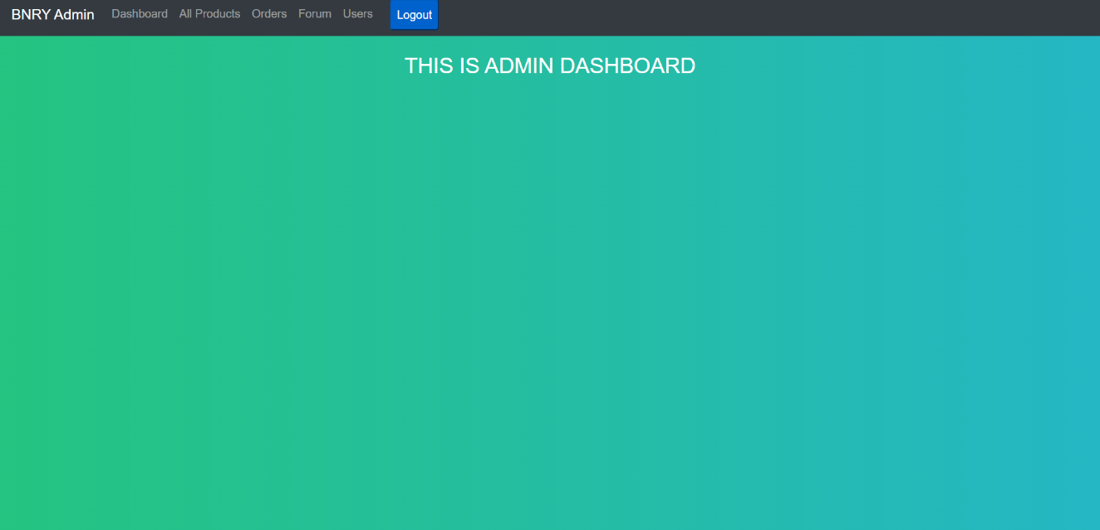

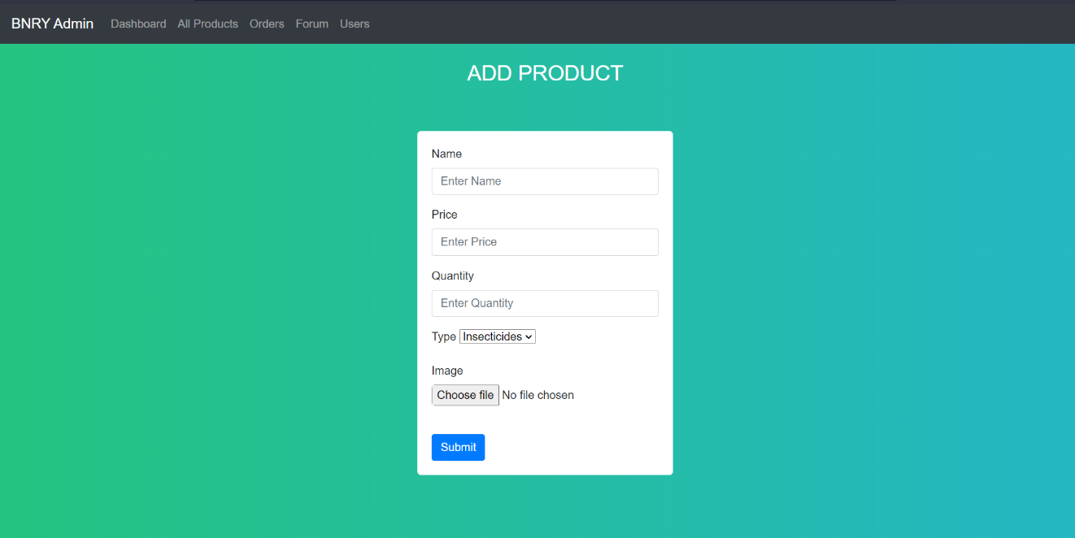

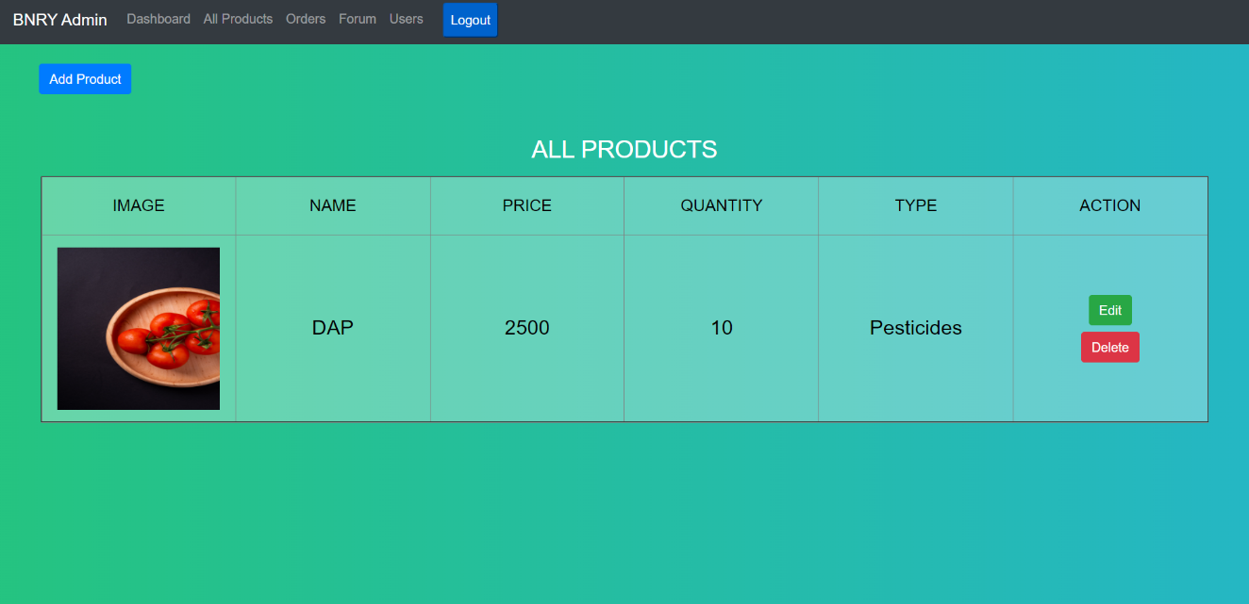



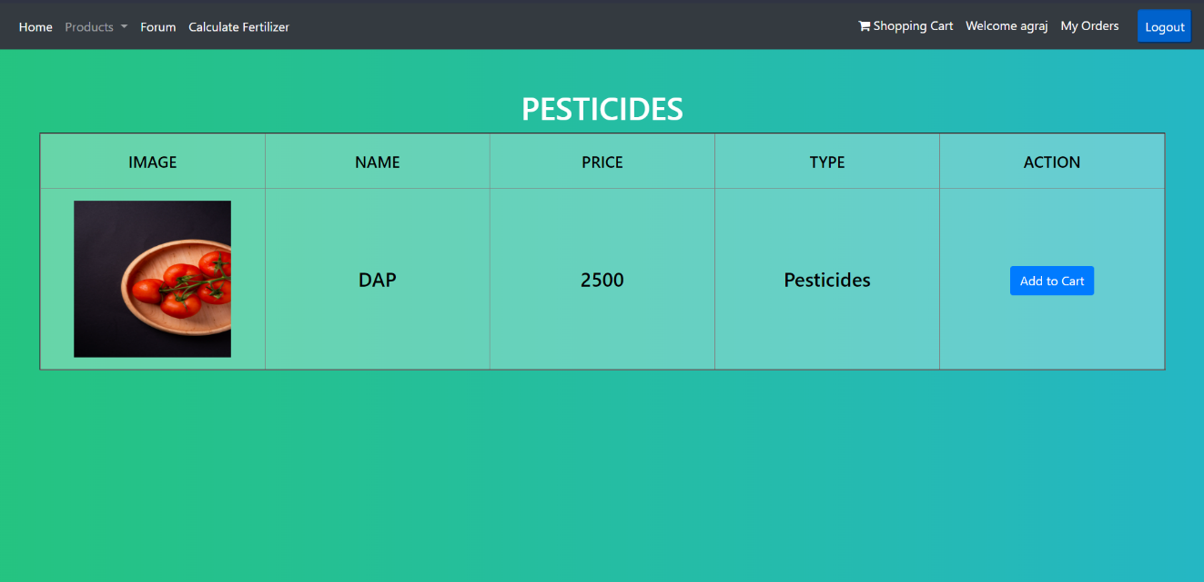





**  
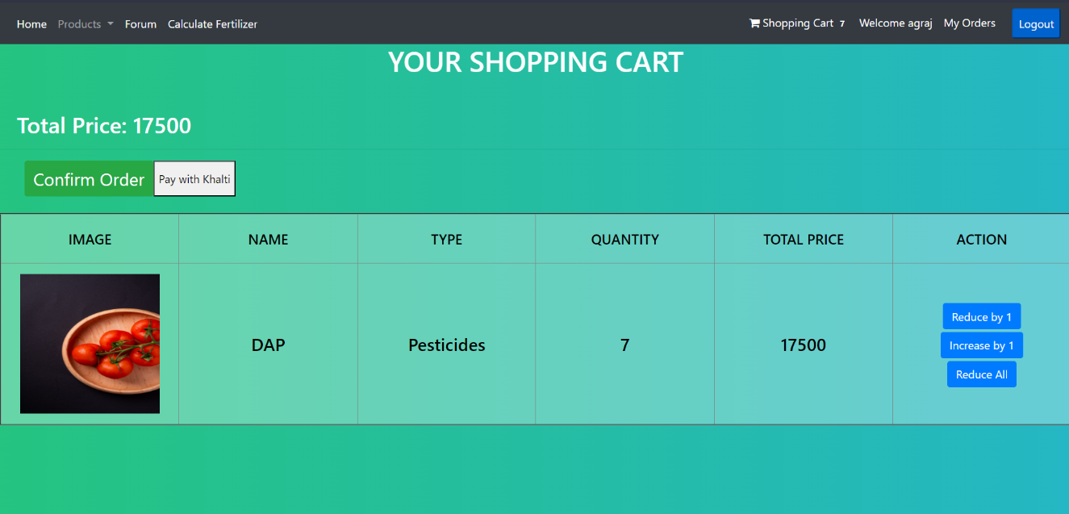**

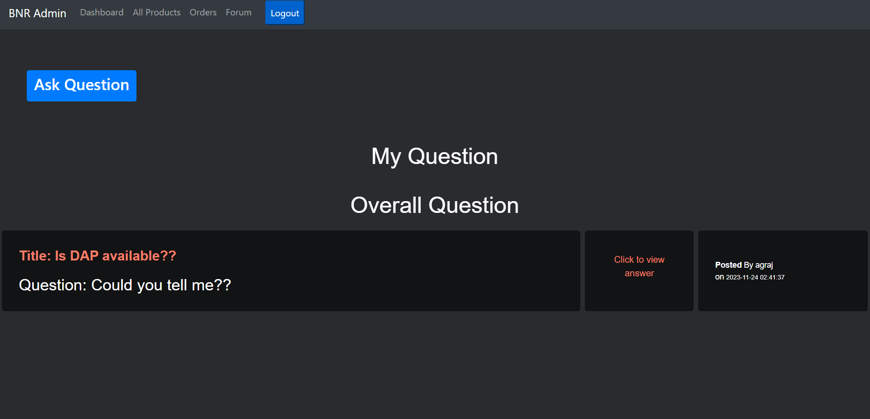

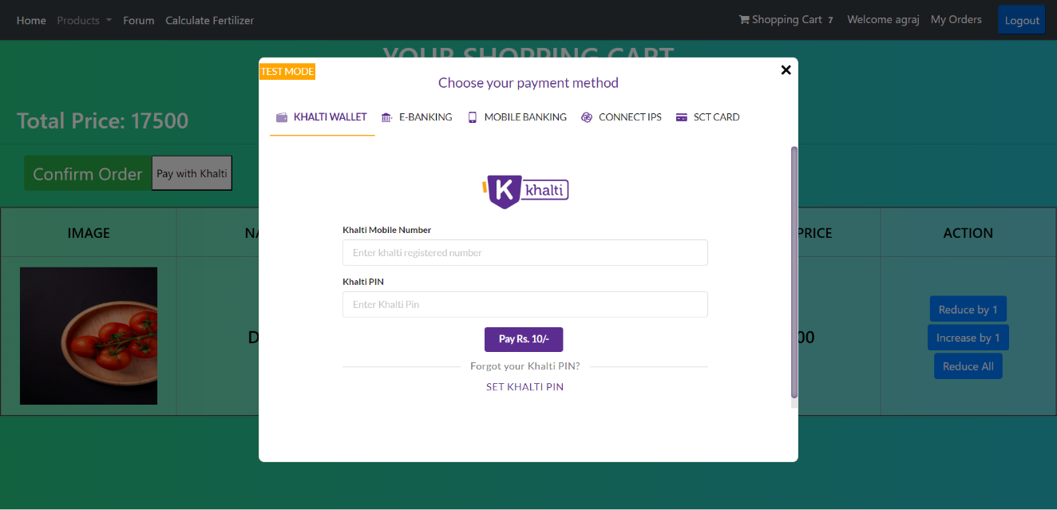



# **Appendix B**

**Source Codes**

**User.php**

<?php

namespace App\Models;

use Illuminate\Contracts\Auth\MustVerifyEmail;

use Illuminate\Database\Eloquent\Factories\HasFactory;

use Illuminate\Foundation\Auth\User as Authenticatable;

use Illuminate\Notifications\Notifiable;

class User extends Authenticatable

{

use HasFactory, Notifiable;

@var array

protected $fillable = [

'name',

'email',

'password',

'deliveryaddress',

'phone',

];

@var array

protected $hidden = [

'password',

'remember_token',

];

@var array

protected $casts = [

'email_verified_at' => 'datetime',

];

public function orders() {

return $this->hasMany('App\Models\Order');

}

public function questions() {

return $this->hasMany('App\Models\Question');

}

public function answers(){

return $this->hasMany('App\Models\Answer');

}

}

**Cart.php**

namespace App\Models;

class Cart

{

public $items = null;

public $totalQty = 0;

public $totalPrice = 0;

public function __construct($oldCart)

{

if($oldCart) {

$this->items = $oldCart->items;

$this->totalQty = $oldCart->totalQty;

$this->totalPrice = $oldCart->totalPrice;

}

}

public function add($item, $id) {

$storedItem = ['qty' => 0, 'price' => $item->price, 'item' => $item];

if ($this->items) {

if(array_key_exists($id, $this->items)) {

$storedItem = $this->items[$id];

}

}

$storedItem['qty']++;

$storedItem['price'] = $item->price * $storedItem['qty'];

$this->items[$id] = $storedItem;

$this->totalQty++;

$this->totalPrice += $item->price;

}

public function reduceByOne($id) {

$this->items[$id]['qty']--;

$this->items[$id]['price'] -=$this->items[$id]['item']['price'];

$this->totalQty--;

$this->totalPrice -=$this->items[$id]['item']['price'];

if($this->items[$id]['qty'] <=0) {

unset($this->items[$id]);

}

}

public function increaseByOne($id) {

$this->items[$id]['qty']++;

$this->items[$id]['price'] +=$this->items[$id]['item']['price'];

$this->totalQty++;

$this->totalPrice +=$this->items[$id]['item']['price'];

if($this->items[$id]['qty'] <=0) {

unset($this->items[$id]);

}

}

public function removeItem($id) {

$this->totalQty-= $this->items[$id]['qty'];

$this->totalPrice -=$this->items[$id]['price'];

unset($this->items[$id]);

}

}

# **References**

1. Khalti. (n.d.). About Us. Retrieved from Khalti: https://web.khalti.com
2. Ltd, K. C. (n.d.). Your Koseli Celebrations. Retrieved from Koseli: https://yourkoseli.com/
3. Mark Otto, J. T. (2011, August 19). Get Bootstrap. Retrieved from https://getbootstrap.com/
4. W3Schools. (1999). Retrieved from 1. https://w3schools.